Laser Carving Machine
Installation and Maintenance Manual
Model: ZYX-C03

Changzhou Zhongyi Computer Systems Research Institute

Notes
- Ground connection
Due to the fact that laser carving operating voltage exceeds 10000V, with increase of atmospheric humidity, there will be some induction. To prevent potential damage to human beings or properties, periodical check shall be conducted to ensure proper ground connection and no static electricity buildup.
- Power source

Extra current leakage protection devices shall be applied when connected to power source to avoid potential damage to human beings or property.
  - Switch on machine
Turn on the computer first, the switch on the carving machine. If the carving machine cart resets, then the connections are right.
Make sure the purifier is working properly
Make sure the cooling water is OK
Make sure that the vacuum pump is working properly.

Construction

PCI card

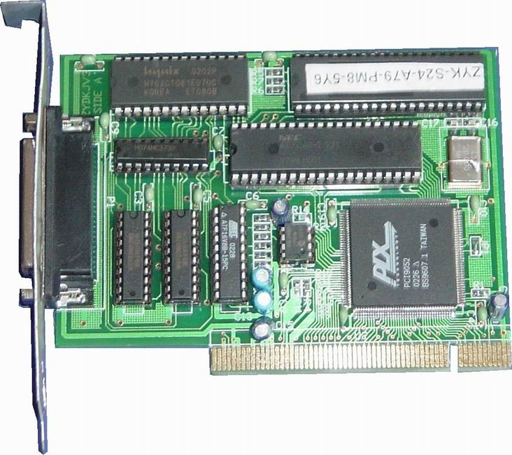
1
2
3
  - PCI 32-bit 33MHZ 5V V2.1 port
  - DB25 printer cable port
  - Machine Serial Number

Mechanical construction

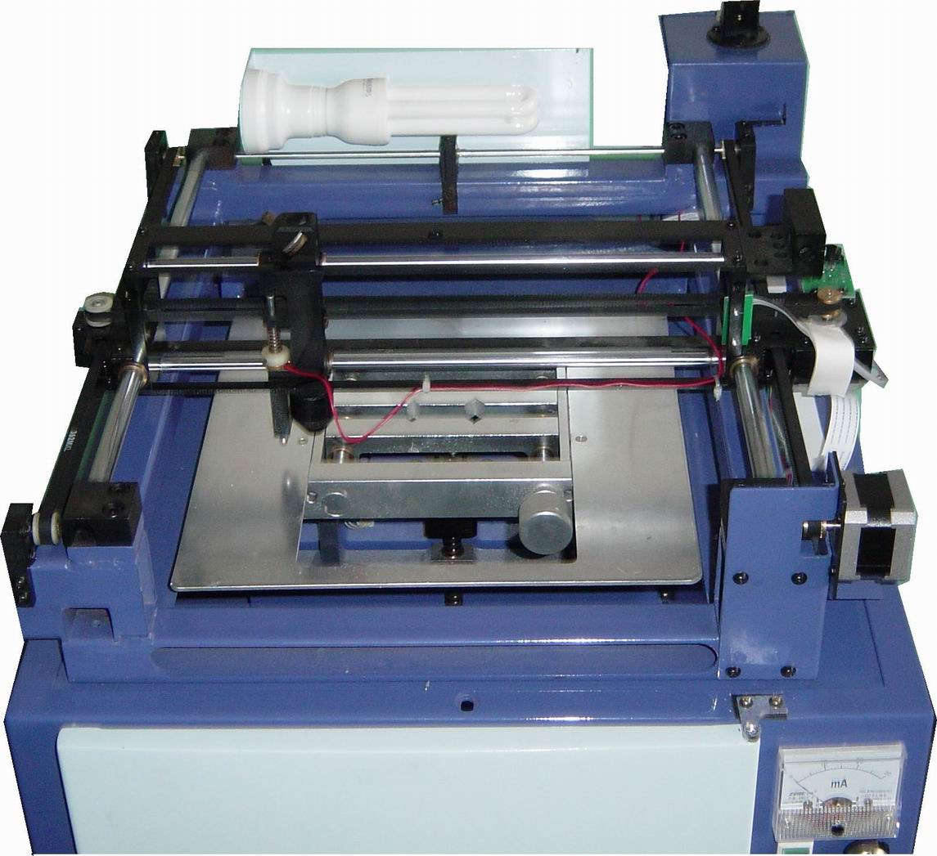
  - X-axis cart
4
1
6
9
3
5
2
8
7
10
  - Y-axis cart
  - Up-down lift (platform)(with fixture)
  - Lightening
  - Laser output
  - Metal probe
  - X-axis indicator
  - Y-axis indicator
  - Focusing Len
  - Mirror

High-voltage Electrical control cabinet
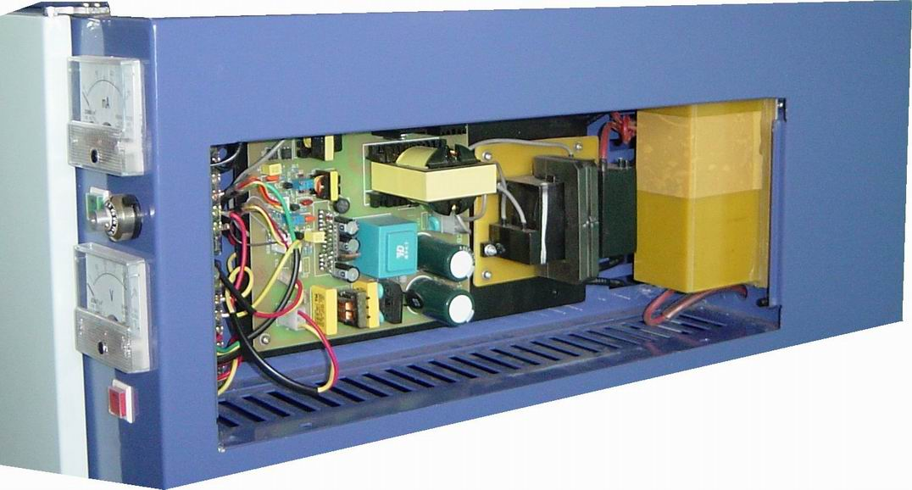
1
2
3

- Power source socket
- Laser power
- Current –limit resistor

Front view

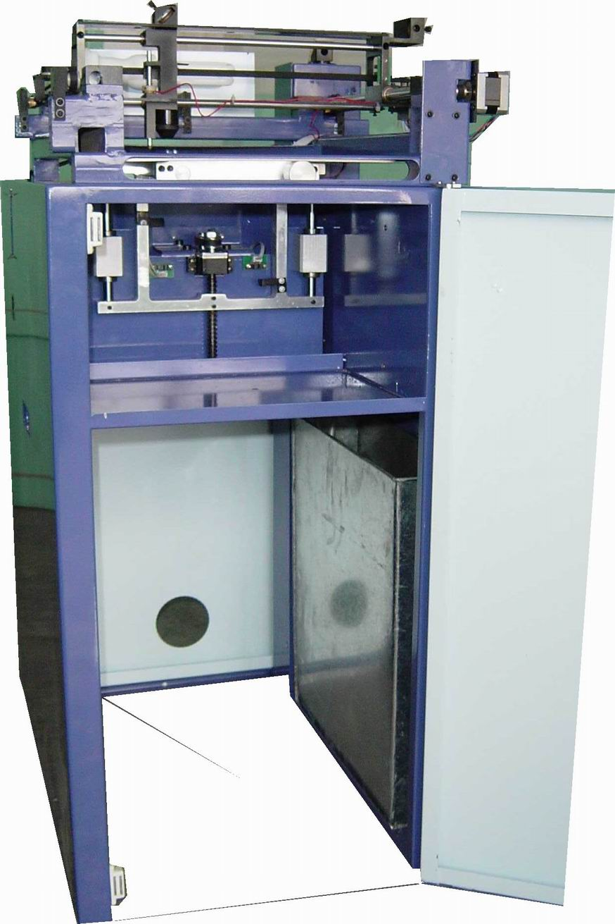
1
2
3

    - Up-down lift platform electric
    - Suction opening
    - Laser cooling water tank

Rear view
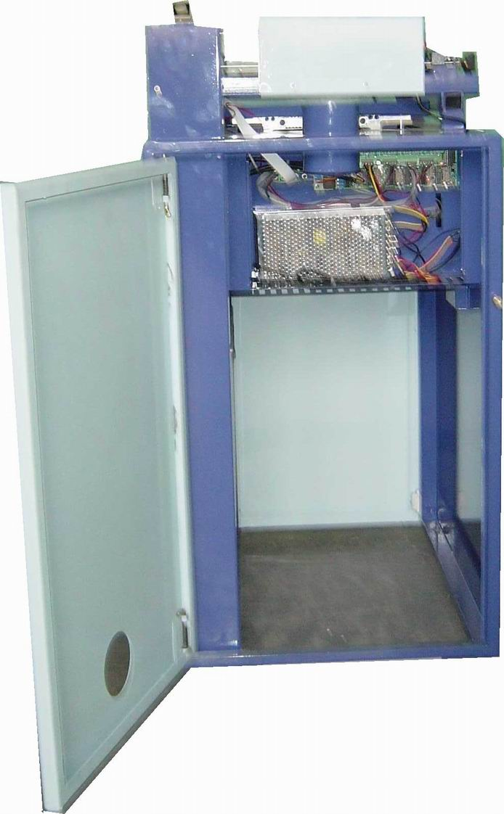
1
2
3
4

    - Laser tube
    - Low voltage power source
    - Suction opening
    - Control board

Left view
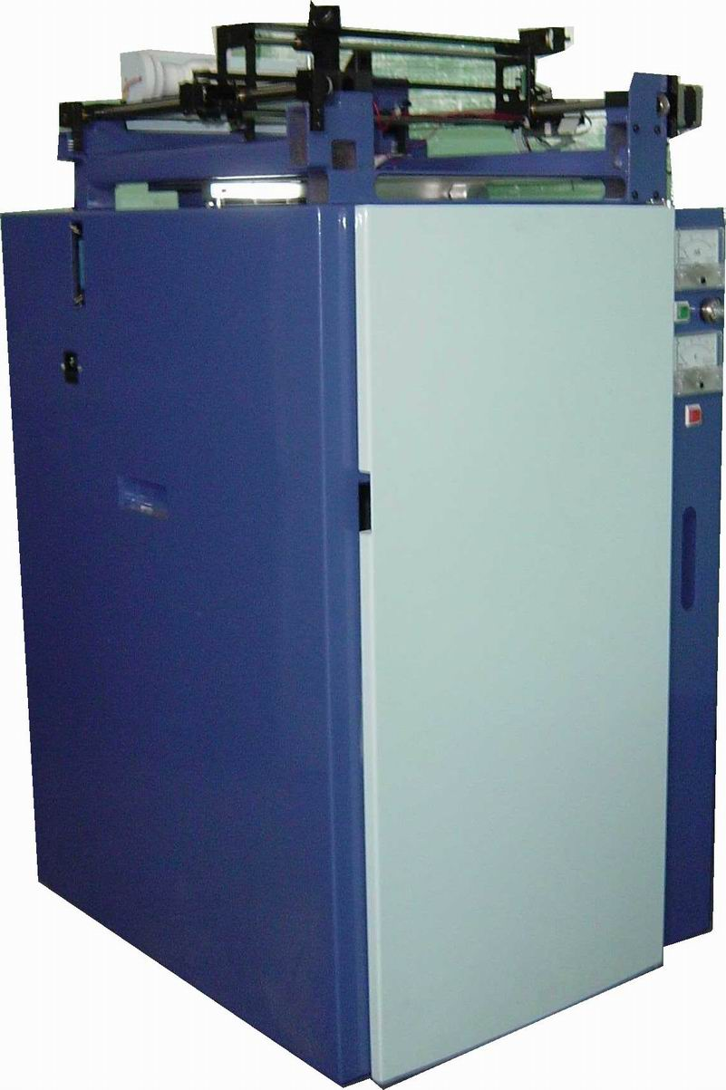
1
2
3
4

    - To power supply of 220V AC 50HZ
    - DB36 printer cable port
    - Extra-long work-piece entry
    - Handle

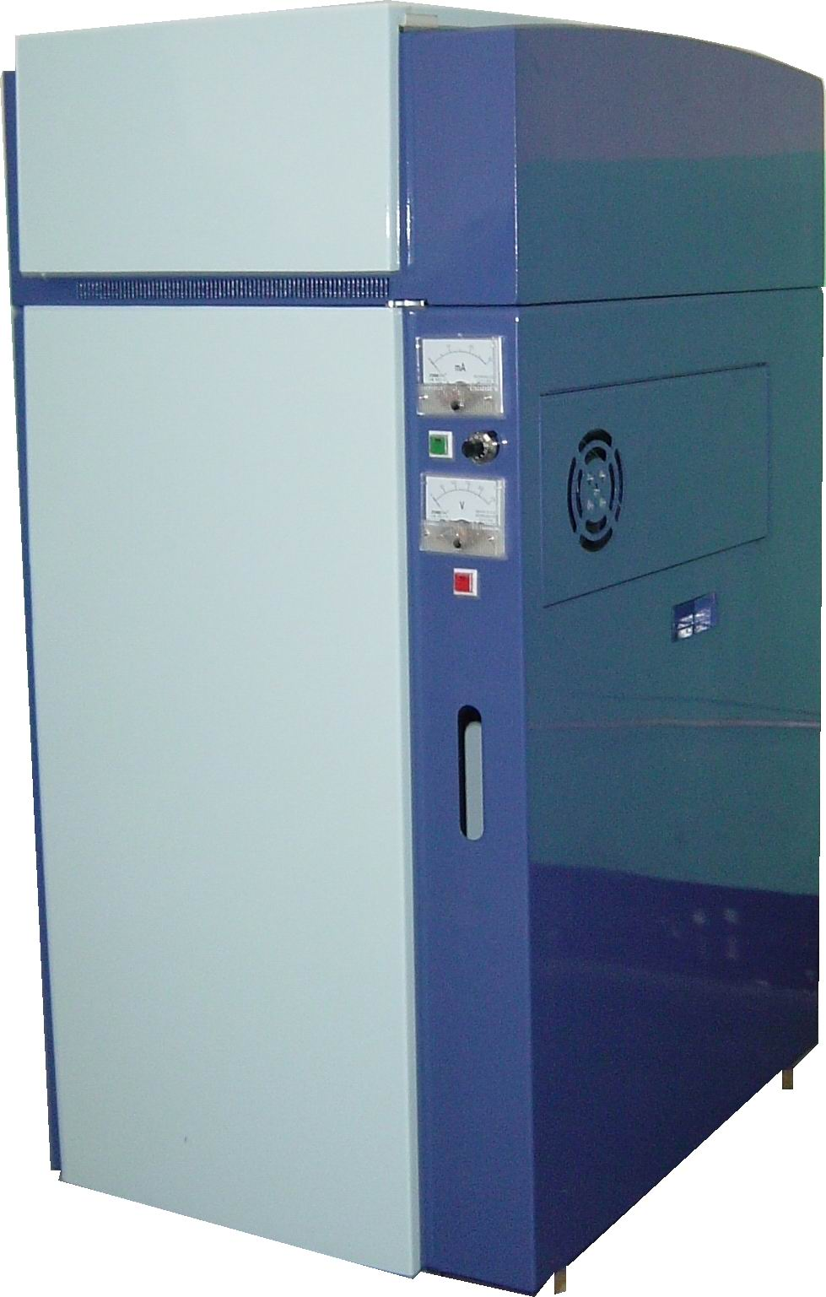
Left side
1
6
7
5
8
3
2
4
9

- Suction opening
- Handle
- Cooling fan
- Power switch
- Volt meter
- Amp meter
- Laser test switch
- External adjusting button for grade 2 current
- Circulating water indicator

Installation and Connection
- PCI card
Turn off the computer，insert the PCI card to any PCI slot in the computer.
- Install driver
When turned on, the computer will search for new hardware. When new hardware is found, install the PCI driver contained on the included CD-ROM to the computer.
- Install application software
Copy and run the application software programs contained on the CD-ROM to computer hard disc，enter serial no and verify before running the programs.
Note: Serial No. Is marked on the chip of PCI card.
- Install purifier
Connect proper ventilation pipes (3 inches) from the carving machine to the air inlet of purifier, and connect pipes from the air outlet from the purifier to outdoors through backdoor. Then switch on purifier to make sure that the purifier functions well. Push the purifier into the bottom case of the carving machine from the front.
- Install cooling water device
Fill adequate amount of water into the cooling water tank (normally 2/3 of volume) and return the tank to its original place.
Note: water pump must be immersed in the water and pipes must be secured properly without loosing.
- Connect computer to carving machine
Connect the printer cable between PCI card and the carving machine.
- Connect carving machine power supply
Note: make sure local power supply matches the carving machine requirements.(220V AC 50HZ)

Operation
- Turn on
Turn on the computer first and then turn on the carving machine. If the cart resets correctly, the connection is OK.
Make sure purifier is in good operation
Make sure cooling water is circulating
Make sure vacuum pump is functioning well.
If OK, follow the next steps.
- Run
Run the programs for carving machine to perform tasks.
- Close
Close the carving machine first and close the computer.

Maintenance and Service
During maintenance, the carving machine hood can be pulled off when necessary. Please refer to illustration.
- X, Y, Z systems and breeching
Periodic cleaning shall be done to carving X, Y, Z systems and breeching. Diluted lubricants shall also be applied to guiding rods of X, Y, Z and Y-axis connector.
- Mirror
Due to long exposure to air, there will be dust build-up which will reduce the reflection and carving output power. Periodic cleaning shall be conducted depending air conditions. When cleaning, take off the mirror，clean the mirror with soft material and alcohol with purity of 99% or over. Make sure that the yellow coating shall not be damaged otherwise the mirror shall be replaced.
- Focusing lens
Focusing lens shall be periodically cleaned as mirror. When mounting be careful about the position. If the position is wrong, the machine will work but the focus will change.
    - By adjusting focus
When the focus is on the same plane with the carving，best carving accuracy and fineness will be achieved. The best focus can be found by using software positioning. The procedure is as follows:
Holding a piece of transparent organic glass at 45 degrees on the fixtures, make holes at 1mm interval by using the positioning and hole-making.(laser current shall be maintained at 10mA) There will be sector formed by different hole depth with the deepest hole (surface point on the organic slope ) as the optimal focus.
    - Cooling water
Cooling water shall be replaced depending on water conditions. In case of lacking water, laser output power will be reduced and depth for carving will become smaller. Lacking water for a long time will cause irreparable damage to the laser tube. Each time after turning on the machine, make sure that cooling water is circulating well. High water temperature will cause less laser output.
- Purifying material
With the increase of workload, the absorbability of the purifying material (active cotton or active carbon) will reduce. Periodic replacement shall be made.

Mechanical repair Instructions
- X-axis adjustment
If movement along X-axis is not smooth or satisfactory, adjustment can be done to X-axis.
    - by adjusting belt (as illustrated)
The carving effects can be improved by adjusting left belt wheel position which results in the adjustment of X-axis belt tension.
    - by adjusting the X-axis guiding rod (Φ8)(as illustrated)
Fine adjustment can be made to the guiding rod above the X-axis. Procedures are as follows: unfasten the retaining screws at both ends of the guiding rod, move X-axis to the left, fasten a bit of the retaining screws at the left of the guiding rod, then move X-axis to the right, fasten a bit of the retaining screws at the right end of the guiding rod, repeat this process for 2-3 times until the retaining screws at both ends are fastened and the cart movement along the X-axis is smooth.
      - Y-axis adjustment
If the movement along Y-axis is not smooth, adjustment of belt can be done to improve. If still not solved, adjustment to the guidance rod of Y-axis.
- By adjusting belt (as illustrated)
Y-axis belt is composed of the left and right lines. There are fixing points on the Y-axis cart among them the central point is the belt-fastening point. The point at 1/4 in front is for adjusting tension under the belt, while the point at 1/4 at rear is for adjusting tension over the belt. When adjusting, unfasten press fixtures at both ends of the belt and after adjusting fasten the press fixtures. If needed, uncover the overhead panel for adjustment. Keep in mind that: tension of each belt and above and under tension of each belt shall remain roughly equal.
- by adjusting Y-axis guiding rod
In case of improper Y-axis movement, adjustment can be done to Y-axis guiding rod. Procedures are as follows: unfasten the press fixture at both ends of the left side of the Y-axis guiding rod, pull Y-axis to the front by hand, fasten the front press fixture retaining screws of the left guiding rod, push the Y-axis back to the back by hand, fasten the back press fixture retaining screws of the left guiding rod, repeat the above for 2-3 times until smooth movement is achieved and the retaining screws are tight. If the above procedures are done and Y-axis movement is still not smooth, the procedures shall be conducted to the left guiding rod.
  - Adjustment of connecting rod
Sometimes the noise of the machine is due to Y-axis connecting rod. If necessary, adjustment can be done to balance the central fixing point of Y-axis.
Note: Items 2, 3, 4 shall be conducted by personnel with mechanical background.
  - Replacing laser tube
The laser tube is consumable. Separate CO2 laser tube normally has life of 1000 hours. When replacing take out the old and replace it with new one. Make sure that the laser tube direction and water pipe inlet and outlet direction cannot be reversed, power polarities shall not be reversed. When replacement is done, adjustment shall be done to the mirror angle so that all laser beam can enter the laser inlet opening (Φ8)of the Y-axis cart, pushing the cart back and forth to ensure the stable entry of laser to the inlet.
Notes：Background knowledge of mechanical, electrical as well as high voltage is needed for this operation.

Fault Analysis
  - Computer does not work
PCI card poor contact
PCI fault
  - Can not enter software program
Wrong set-up of PCI port with computer
PCI fault
  - Program does not carve
Carving machine is not powered on, or fuse burnt out
Poor cable connection
Low voltage power source fault, main board not powered on (no indicator, low voltage power source does not work)
Main board fault
  - abnormal X、Y、Z movements
No movement
No motor connection
Main board fault
Motor fault
Movement without stop
Limit indicator coupler fault
Abnormal movement
No motor connection
Main board fault
High voltage induction（check grounding connection and high voltage, and current limiting resistor burned out or not）
Motor fault
Mechanical fault（X、Y、Z-axis）
  - No laser
No laser whether manual or program
Poor connection of laser
Current limiting resistor damaged, laser power damage
Laser tube fault
Optical circuit fault
Laser when manual operated, no laser program operated
Main board fault
No laser when manually operated, laser when program operated.
Main switch connection fault.
  - Preset ionizing too high（there is beam when laser is not switched on）
Adjust preset ionizing potential meter on the laser power source
Laser source does not match power tube
  - Max. Current limiting
Adjust maximum current potential meter (increase clockwise)
  - Laser becomes faint
Out of water
Too high water temperature
Laser tube worn out due to long service
Mirror damaged
Wrong focus, focusing Len damaged
Deviation of optical circuit
Wiring Diagram

